**Experiment 1.4**

**Aim/Overview of the practical:**

* How to deploy a web application by using GitHub on Azure portal?

**Code/Steps for the Practical :**

**Step 1)** Create a Static web app/page on your local machine which you want to deploy on Azure Portal.

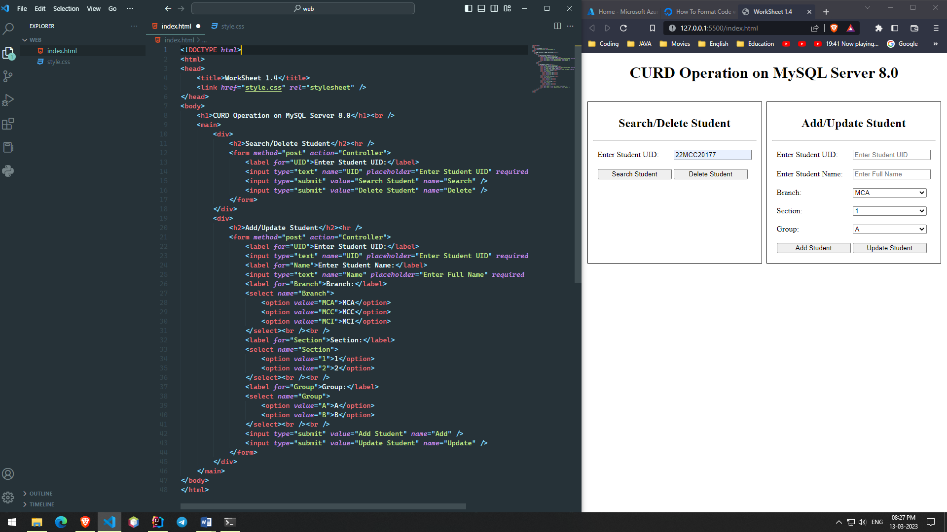

**Step 2)** Create a new Repository on GitHub.

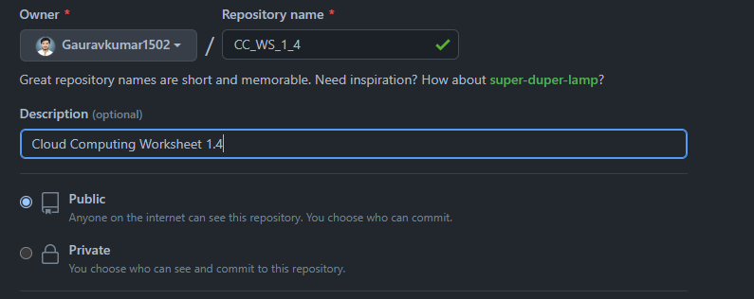

**Step 3)** Push your web Application to your newly created Repository on GitHub using Git CLI or GitHub drag and drop feature.

**Step 4)** After file uploaded on GitHub open Azure portal and Click on **Create a resource** select **Web App**

And fill the all details and then click on **Review+Create**.

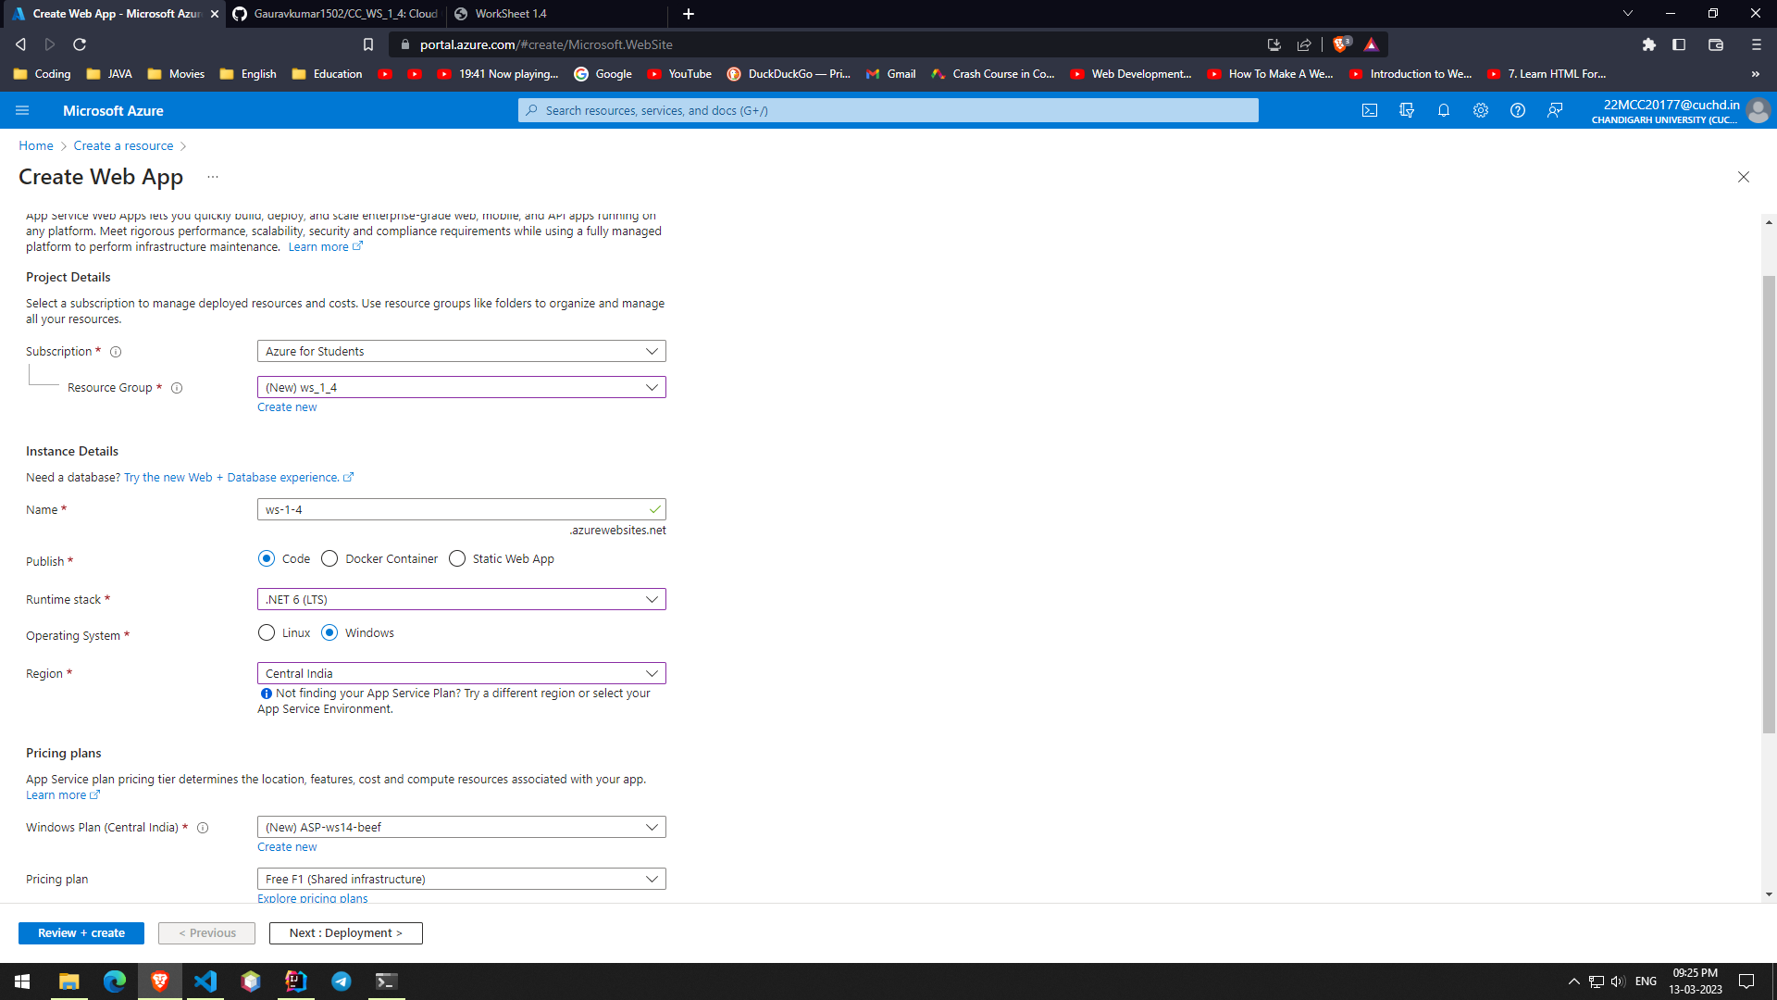

**Step 5)** Once your web app has been created, select your web app and navigate to the "Deployment Center" tab under "Deployment" in the left-hand menu.

**Step 6)** In the Deployment Center, select the **Source as "External Git"** and then enter the URL of GitHub Repository, branch name and branch type and then Click Save.

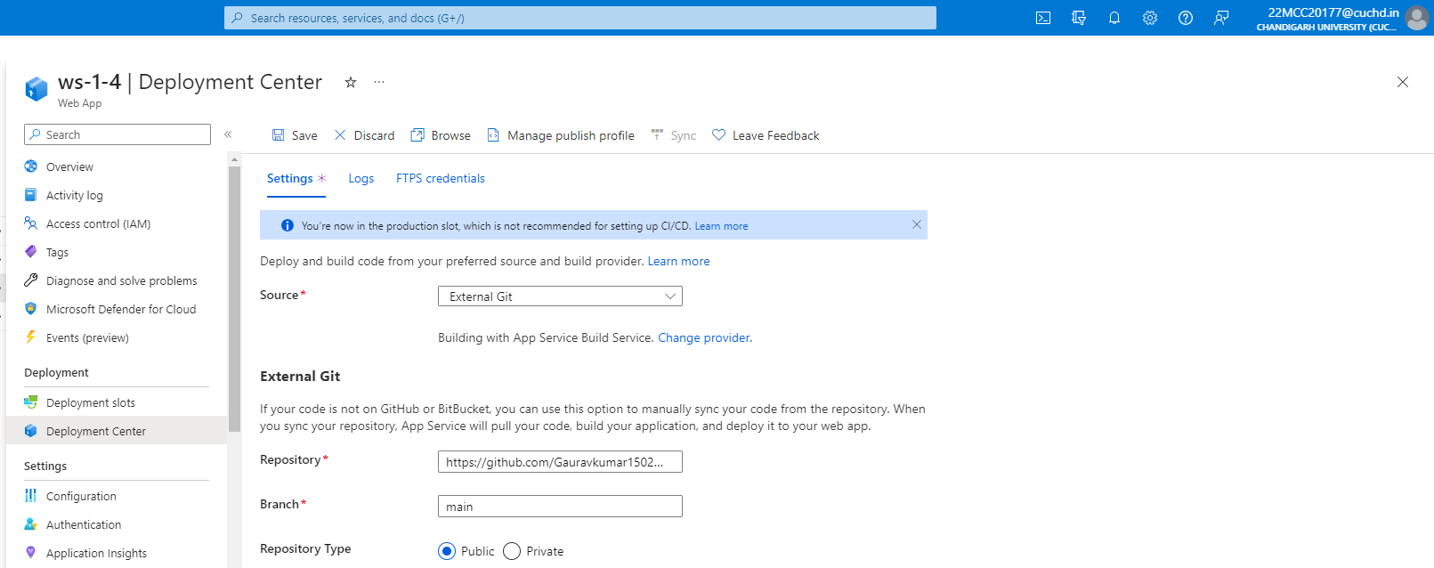

**Step 7)** Once the deployment is complete, you can browse to your web application by clicking the "Browse" button on the app's Overview page.

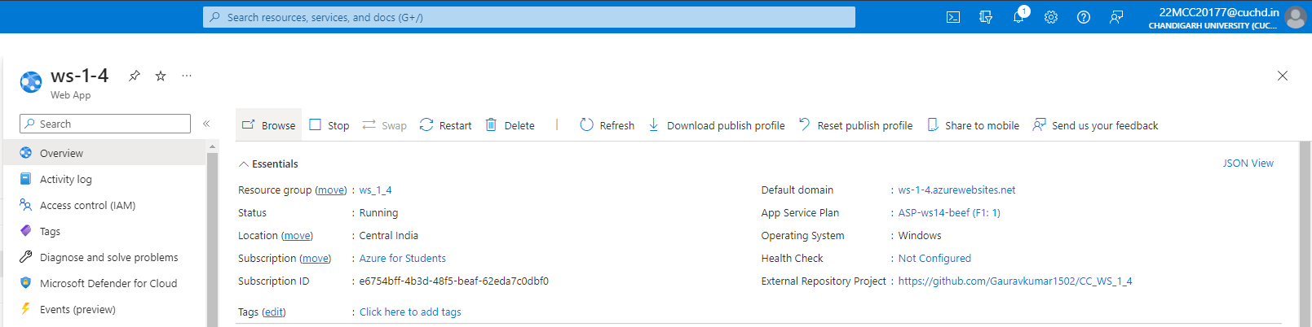

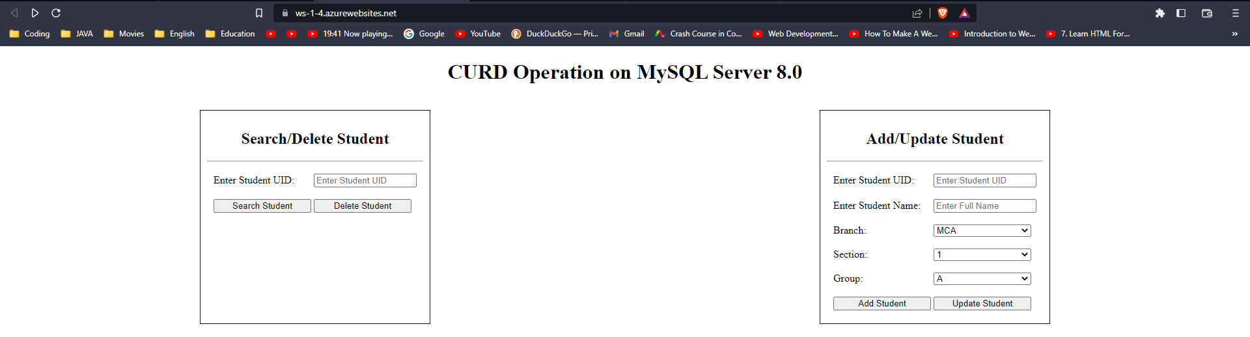

**Learning Outcomes (What I have learned)**

* I Learned to: -
  + - * Create resource in the azure portal
      * To deploy the web app on the azure portal using GitHub.

**Evaluation Grid:**

|  |  |  |  |
| --- | --- | --- | --- |
| Sr. No. | Parameters | Marks Obtained | Maximum Marks |
| 1. | Demonstration and Performance  (Quiz) |  | 22 |
| 2. | Worksheet |  | 8 |